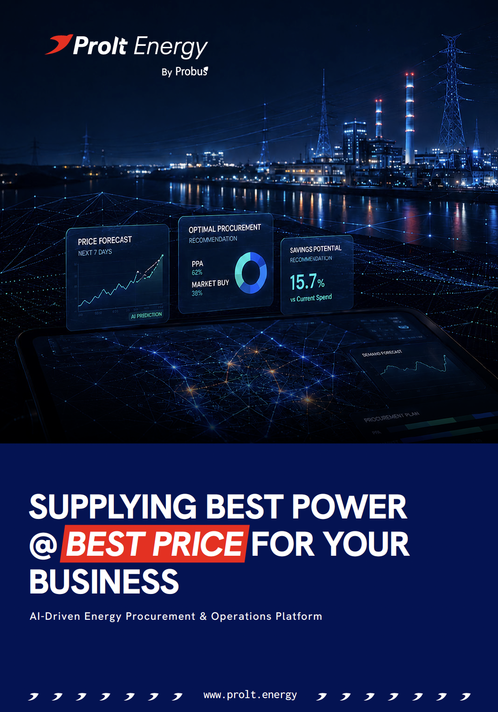
1. EXECUTIVE SUMMARY

TECHNICAL PROPOSAL FOR XXXXXXXXXXXXX
A clear, quantified opportunity to reduce energy cost through data-led procurement and managed Open Access execution.

Sanctioned Load | Connectivity | DISCOM Name | Feeder Type
1000 KVA | 11 KV | PUVVNL | Dedicated

THE OPPORTUNITY
A savings proposal built from Chaurishi Ayurveda LLP’s actual utility bills and consumption data.

AVERAGE MONTHLY SAVINGS  ₹2,11,034  Estimated from actual energy bills shared with Probus. | AVERAGE ANNUAL SAVINGS  ₹25,32,409  Direct opportunity to improve operating margins. | FIXED-COST PAYBACK  Less than 150 days  Following payback, savings flow directly to the business.

THE PROPOSAL
Move from a largely single-source electricity model to a managed procurement model that combines DISCOM supply, Open Access, exchange-based procurement, green power, solar, and battery storage wherever commercially viable.

WHAT PROLT CHANGES?

Prolt moves the business from a largely single-source electricity model to a managed, multi-source procurement model that combines DISCOM supply, Open Access, exchange-based procurement, green power, solar and other commercially viable sources.
AI-DRIVEN OPTIMISATION  Forecast demand and evaluate tariffs, market prices and available sources to identify the most economical procurement mix. | 15-MINUTE ENERGY VISIBILITY  Use interval data to align procurement with actual demand and improve control over consumption and cost.
LOWER LANDED ENERGY COST  Continuously optimise the blended cost of electricity while maintaining reliability and operational continuity. | END-TO-END EXECUTION  Support procurement planning, scheduling, metering coordination, reconciliation and ongoing savings tracking.
MARKET + REGULATORY INTELLIGENCE  Combine market monitoring with Open Access and utility requirements to support timely, compliant decisions. | ONE MANAGED PLATFORM  Bring consumption, sourcing, landed cost and realised savings into a single transparent operating view.

THE OBJECTIVE
Supply the best available energy to your business at the lowest possible landed cost, while maintaining reliability and regulatory compliance and operational continuity.
Prolt Energy is an AI-driven energy procurement and operations platform for commercial and industrial consumers. It helps C&I Consumer source cost-effective power through a combination of DISCOM supply, Open Access, exchange-based procurement, green power, solar, and battery storage, wherever commercially viable. to your bus

THE DECISION
Proceed with the Open Access implementation journey and let Probus manage the full operating cycle - from application and metering to daily energy buying, settlement, and reporting powered by our AI driven platform – Prolt Energy.

Open Access timeline: 60-90 days

LOWER POWER COST. BETTER PROCUREMENT. COMPLETE VISIBILITY.

2. KEY CHALLENGES
Energy Procurement for Businesses is Still Reactive, Opaque and Inefficient.
For businesses, electricity is one of the largest operating costs – yet power buying is still managed through fragmented suppliers, manual decisions, limited visibility, and unclear pricing. This leaves businesses with higher costs, poor control, and limited transparency. The key issue is not only the tariff. It is the absence of continuous, time-block-level procurement decisions.
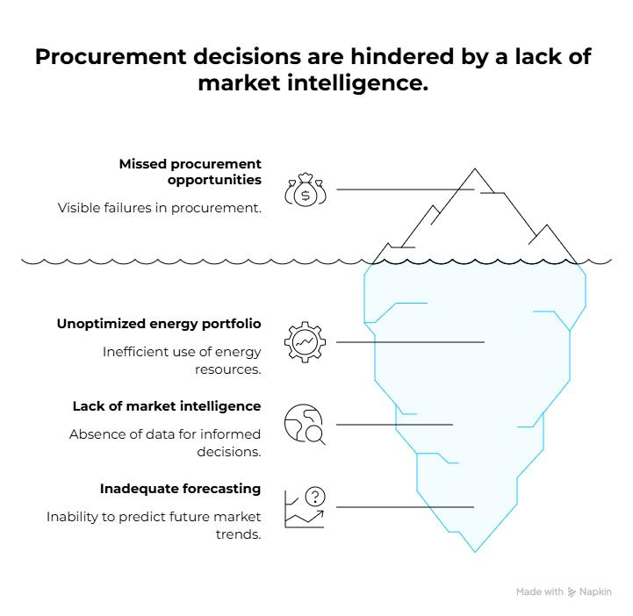
- Commercial and industrial consumers face high electricity costs due to DISCOM tariffs, peak-period charges, demand charges, and limited access to lower-cost procurement options.
- Monthly bills provide limited visibility into 15-minute block-wise consumption, time-of-day costs, peak demand, and the actual drivers of energy expenditure.
- Open Access involves complex execution across approvals, metering, scheduling, settlements, compliance, and coordination with SLDC, DISCOM, traders, and suppliers.
- Without forecasting, market intelligence, and real-time price visibility, procurement decisions remain largely manual, leading to missed opportunities, inefficient sourcing, and higher energy costs.
TODAY  - Single-source dependency  - Monthly review  - Fragmented coordination | → |   WITH PROLT  - Multi-source strategy  - Time-block intelligence  - Managed energy operations with full transparency

3. PROLT ENERGY SOLUTION
Prolt Acts as Your Business’ Intelligent Energy Procurement Partner.
We analyse your business’ bills, load profile, tariff category, contract demand, sanctioned load, demand charges, power factor, and applicable open access rules. Based on this, Prolt designs a practical energy procurement strategy using the most suitable mix of:

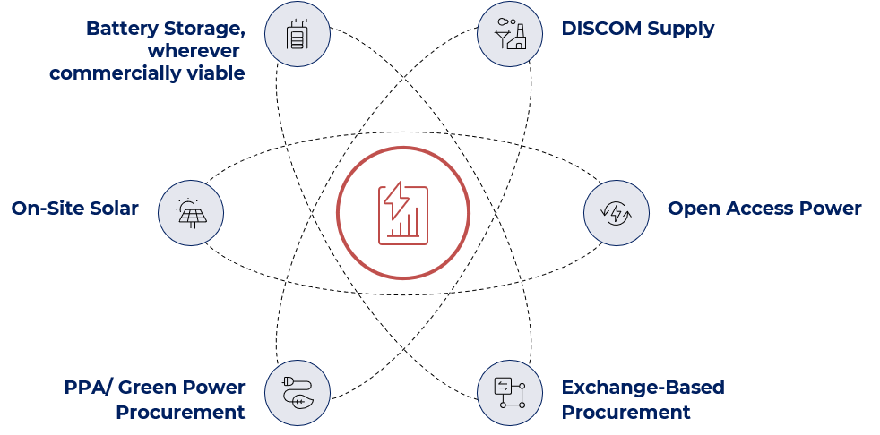
The goal is to reduce landed cost without compromising reliability. Powered by an AI-Driven platform, Prolt Energy continuously selects the most cost-efficient and reliable energy mix at every 15-minutes and delivers to your business with guaranteed delivery. Prolt Energy brings together energy procurement, operations, monitoring and reporting into one transparent supply platform --- ensuring reliable delivery, optimized cost and measurable savings for your business.

Built for Businesses with Demand from 100 kW onwards

4. PROPOSED SCOPE OF WORK

A structured Path from Diagnosis to Ongoing Operations

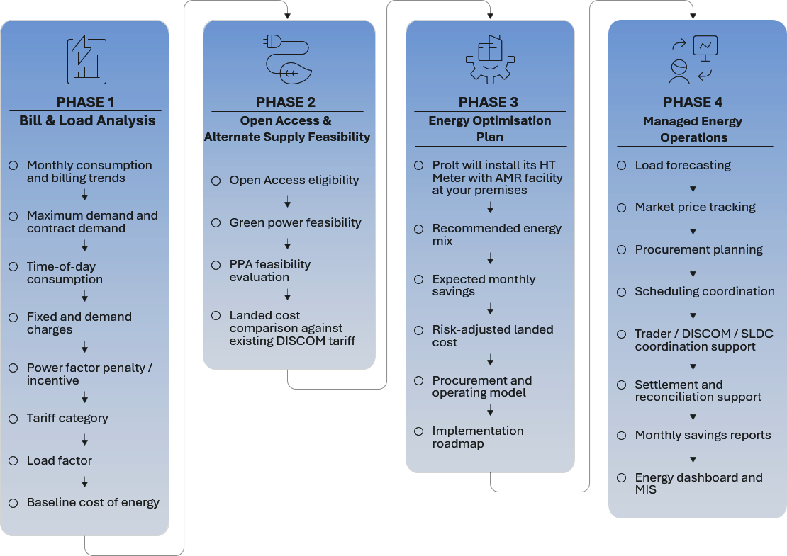

The proposed scope follows a progressive, data-led approach, moving from understanding the existing energy cost structure to implementing and managing an optimised procurement strategy.

- Prolt establishes the baseline cost of energy by analysing consumption trends, demand behaviour, TOD usage, tariff structure, load factor, and applicable penalties or incentives.

- Based on the baseline, Prolt evaluates Open Access eligibility, Green Power, PPA options, and landed cost comparisons to identify commercially viable alternatives to the existing DISCOM tariff.

- Prolt translates the feasibility study into an actionable plan covering the recommended energy mix, expected savings, risk-adjusted landed cost, procurement model, and implementation roadmap, supported by the Prolt Meter and AMR-based monitoring.

- Once implemented, Prolt continuously manages load forecasting, market monitoring, procurement planning, scheduling, coordination, settlement, reconciliation, and savings reporting through a single managed energy platform.

Prolt Energy provides is a complete journey from diagnosis → feasibility → optimisation → execution, with clear visibility of cost, savings, risk, and procurement performance at every stage.

5. MANAGED ENERGY OPERATIONS

More than Analysis: Prolt Manages the Operating Cycle

The platform combines intelligence with execution, visibility, and accountability. Prolt turns 15-minute energy data into day-to-day procurement execution - forecasting demand, selecting the best source, coordinating schedules, reconciling every unit, and proving realised savings.

 |  |  |  | 
FORECAST  Load + Price  15-min demand, ToD exposure and market price outlook | PLAN  Best Source Mix  Compare DISCOM, OA, exchange and green power on landed cost | SCHEDULE  Execute Daily  Coordinate procurement, revisions and SLDC / DISCOM / trader actions | SETTLE  Reconcile Every Unit  Match schedules, meter data, deviations and invoices | REPORT  Prove Savings  Track source mix, landed cost, exceptions and monthly savings

EXPECTED BUSINESS BENEFITS

- Lower monthly electricity cost, with up to 30% monthly energy bill reductions.
- Real-time visibility into energy consumption and cost.
- A clear comparison between DISCOM and alternate supply options.
- Reduced complexity in Open Access and market-based procurement, with full transparency.
- Data-driven energy decisions supported by forecasting and market intelligence.
- Monthly savings tracking and transparent reporting.
- A future-ready power procurement model.
FROM MONTH-END REVIEW TO CONTINUOUS ENERGY CONTROL

Traditional Approach | Prolt Energy Approach
Monthly bill review | 15-minute energy intelligence
Single-source dependency | Multi-source energy strategy
Manual procurement decisions | AI-assisted forecasting & procurement planning
Tariff-only comparison | Full landed-cost comparison, including OA-related charges
Fragmented coordination | Managed scheduling, settlement and compliance support
Estimated savings | Reconciled, traceable and reported realised savings

WHAT PROLT MANAGES FOR YOU

DAY-TO-DAY ENERGY OPERATIONS  • 15-minute load and price forecasting  • Source selection and market monitoring  • Scheduling, revisions and exception handling  • Coordination with trader / DISCOM / SLDC | SETTLEMENT & PERFORMANCE CONTROL  • Meter and schedule validation  • Deviation / settlement and invoice reconciliation  • Landed-cost and source-wise savings attribution  • Monthly MIS, audit trail and management reporting

FORECAST BETTER. BUY SMARTER. RECONCILE EVERY UNIT. PROVE EVERY SAVING.
*Savings depend on load profile, market prices, applicable charges, OA eligibility and prevailing regulations.

6. ANALYSIS INPUTS & DELIVERABLES
Everything Required to Move from Feasibility to Execution
A clear input checklist, matched to decision-ready outputs and an actionable implementation roadmap.
INFORMATION REQUIRED  1. Last 12 months electricity bills  2. Sanctioned load and contract demand details  3. Connected load details  4. Existing tariff category  5. 15-minute or 30-minute load data, if available  6. Details of existing solar installation, if any  7. DG set / backup power details  8. Operating pattern or production schedule  9. Planned capacity expansion, if any | DELIVERABLES  1. Electricity bill analysis report  2. Baseline energy cost report  3. Open Access feasibility report  4. Landed cost comparison  5. Expected savings estimate  6. Energy procurement strategy  7. Implementation roadmap  8. Commercial proposal for managed energy services
WHAT THE ANALYSIS MAKES CLEAR
BASELINE COST  Current landed cost | ELIGIBLE LOAD  OA-ready volume | BEST SOURCE MIX  Recommended portfolio | SAVINGS  Monthly / annual | GO-LIVE PATH  Actions & timeline

HOW PROLT CONVERTS DATA INTO ACTION
01  VALIDATE  Bills, interval data & contract details | → | 02  DIAGNOSE  Cost drivers, load pattern & tariff impact | → | 03  COMPARE  OA, green power, exchange & other options | → | 04  DECIDE  Recommended mix, savings & implementation path

ENGAGEMENT MODEL
DIAGNOSTIC STUDY  Establishes the baseline, feasibility, savings case and execution roadmap. | → | MANAGED ENERGY SERVICE  Procurement planning, forecasting, market monitoring, scheduling, reconciliation, savings tracking and reporting.
Every Recommendation is Traceable to Supplied Consumption Data, Applicable Tariffs, Market Charges and Open Access Rules.

ANALYTICAL FRAMEWORK USED BY PROLT
01 | CONSUMPTION & DEMAND  Profiles energy use by time block, maximum demand, load factor and operating pattern to identify where cost is being created. | 02 | TARIFF & LANDED COST  Separates tariff components, demand charges, ToD impact and applicable Open Access charges to establish the true landed cost of every option.
03 | ALTERNATE SUPPLY OPTIONS  Tests Open Access, exchange power, green power / PPA, solar and other viable sources against eligibility, availability, price and risk. | 04 | IMPLEMENTATION READINESS  Checks metering, approvals, scheduling, data availability and stakeholder dependencies to convert the selected strategy into an executable plan.

MANAGEMENT DECISIONS ENABLED
GO / NO-GO  Whether alternate procurement is commercially viable and the expected payback / savings case. | WHAT TO PROCURE  Recommended source mix, eligible load and commercially preferred procurement route. | HOW TO IMPLEMENT  Clear sequence for metering, approvals, contracting, scheduling and managed operations.

DATA VALIDATION PRINCIPLE
All savings, landed-cost comparisons and procurement recommendations are calculated from customer-supplied consumption data, applicable tariff / market charges, regulatory rules and clearly stated assumptions.

FROM RAW ENERGY DATA TO A QUANTIFIED, EXECUTABLE PROCUREMENT DECISION

7. SAVINGS FOR YOUR BUSINESS
The Savings Opportunity is Consistent Across the Billing History
Actual data shows a recurring reduction opportunity, with the strongest saving in May 2026.
AVERAGE MONTHLY SAVINGS  ₹2,11,034  Estimated from the historical energy bills and consumption data provided. | ANNUALISED SAVINGS OPPORTUNITY  ₹25,32,409  Indicative annual opportunity from shifting to a managed procurement model. | STRONGEST OBSERVED MONTH  ₹3,21,884  May 2026 - highest saving observed in the six-month billing history.



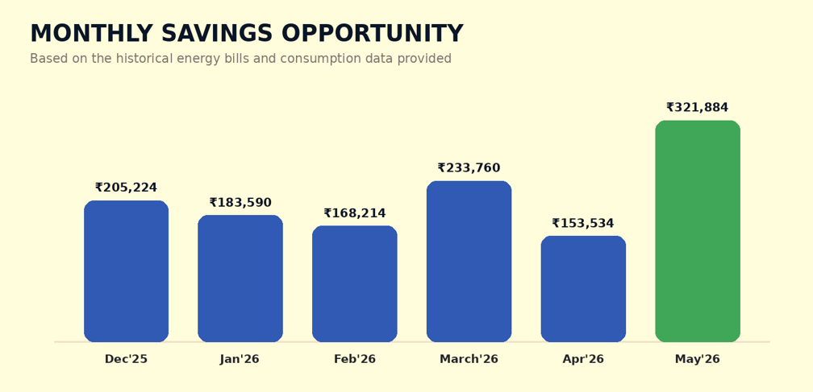
Avg. ₹2.11 lakhs

6 / 6  MONTHS POSITIVE  Savings opportunity appears in every observed month. | 84% - 99%  OA SHARE  A high proportion of actual units can be modelled through OA. | ₹1.55L - ₹3.22L  MONTHLY RANGE  Observed savings range across the six-month history. | ₹1.95 - ₹3.20  SAVING / UNIT  Per-unit saving observed across the billing months.
Recurring Opportunity: delaying the transition can leave approximately ₹25 lakh per year of savings unrealised.

Six Months of Customer-Specific Savings Evidence
The figures below are reproduced from the savings analysis prepared for Chaurishi Ayurveda LLP.
Bill Months | Billing Period | Actual Units | % Cleared Units through OA | Power Purchase Cost |  |  |  | Savings
 |  |  |  | DISCOM  only |  | Prolt Mix (OA+DISCOM)
 |  |  |  | Total | Per Unit | Total | Per Unit | Total | Per Unit
Dec'25 | 01/12 - 31/12 | 1,05,107 | 98% | ₹ 8,15,506 |  | ₹ 6,10,282 |  | ₹ 2,05,224 | ₹ 1.99
Jan'26 | 01/01 - 31/01 | 1,01,142 | 93% | ₹ 7,35,555 |  | ₹ 5,51,964 |  | ₹ 1,83,590 | ₹ 1.95
Feb'26 | 01/02 - 28/02 | 86,184 | 99% | ₹ 6,70,614 |  | ₹ 5,02,401 |  | ₹ 1,68,214 | ₹ 1.97
Mar'26 | 01/03 - 31/03 | 1,02,300 | 87% | ₹ 7,11,324 |  | ₹ 4,77,565 |  | ₹ 2,33,760 | ₹ 2.63
Apr'26 | 01/04 - 30/04 | 89,976 | 84% | ₹ 5,83,239 |  | ₹ 4,29,705 |  | ₹ 1,53,534 | ₹ 2.03
May'26 | 01/05 - 31/05 | 1,01,370 | 99% | ₹ 7,77,080 |  | ₹ 4,55,197 |  | ₹ 3,21,884 | ₹ 3.20
Note: Savings are indicative and based on the customer data and assumptions used in the analysis. Actual savings may vary with consumption, market prices, Open Access charges, approvals and applicable regulations.

8. Savings Summary Snapshot
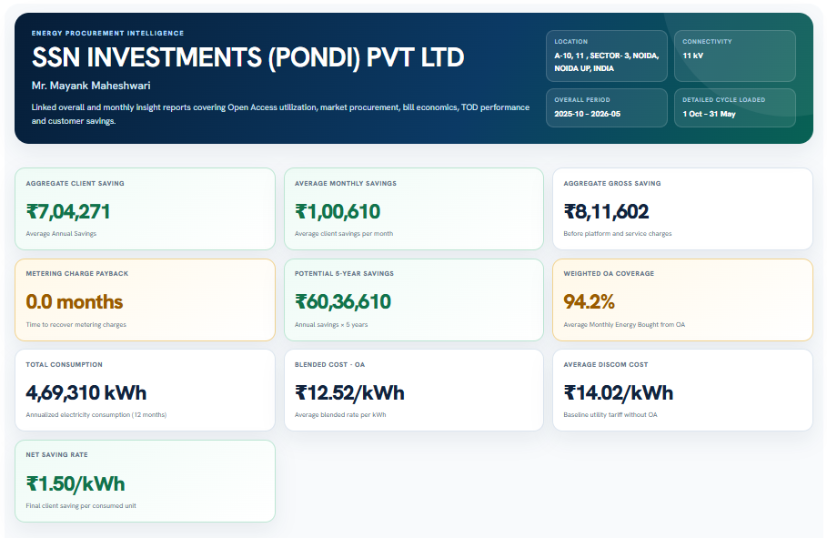
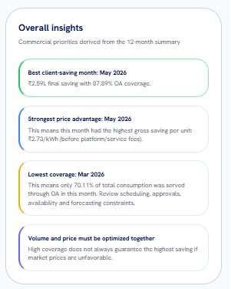
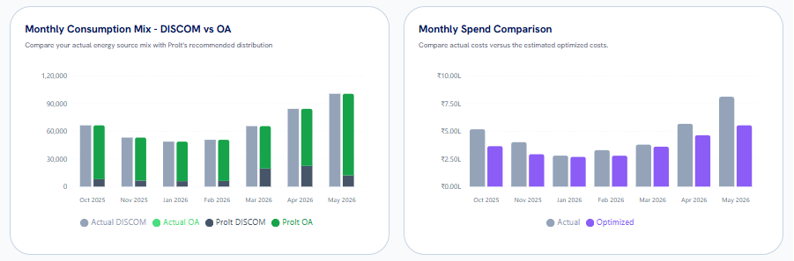


9. SOME INSIGHTS FROM PROLT PLATFORM

Prolt Savings Calculator

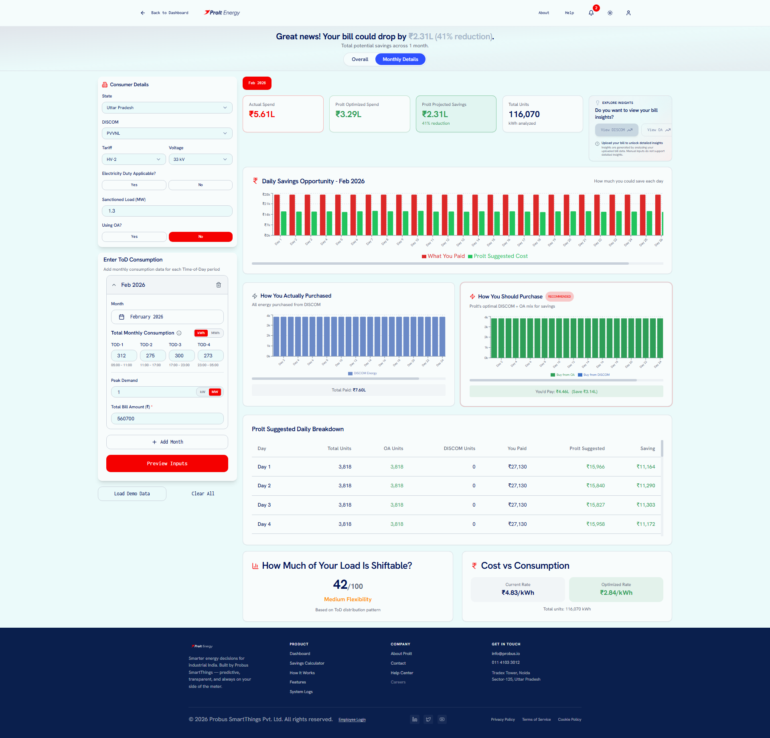

The complete analysis is generated within the Prolt application, giving users one transparent view of consumption, procurement opportunity, recommended sourcing and savings.

FROM RAW ENERGY DATA → TO SMARTER PROCUREMENT → TO MEASURABLE SAVINGS

Prolt Real-Time Meter Data

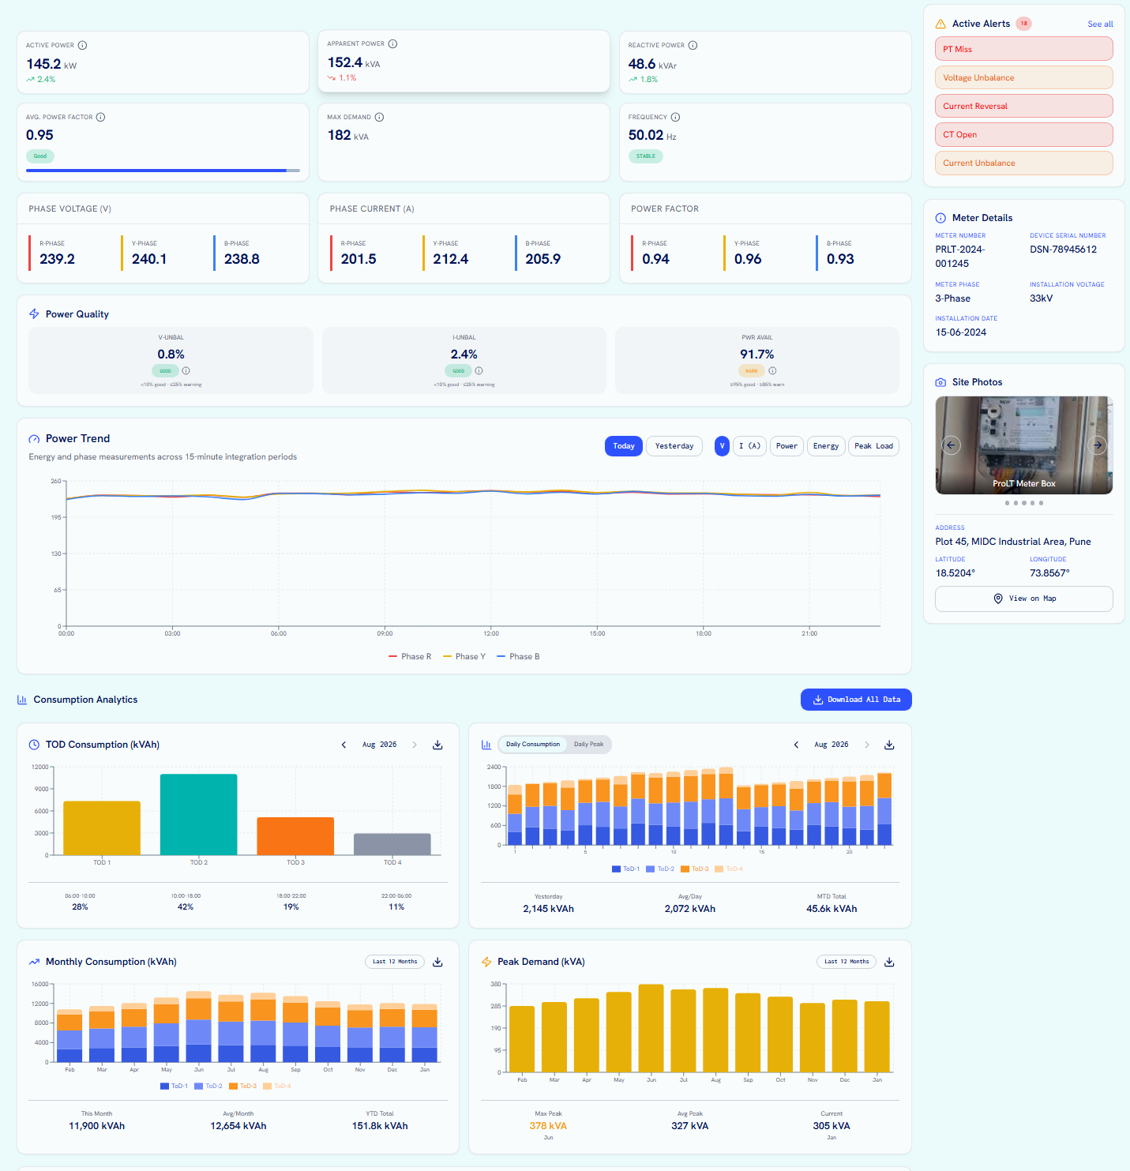

Visit https://prolt.energy/, upload your energy bills, and instantly discover how much your business can save.

Get Prolted — and start saving on energy from Day 1

10. EXECUTION TIMELINE
A Managed Implementation Journey, Led End to End by Prolt

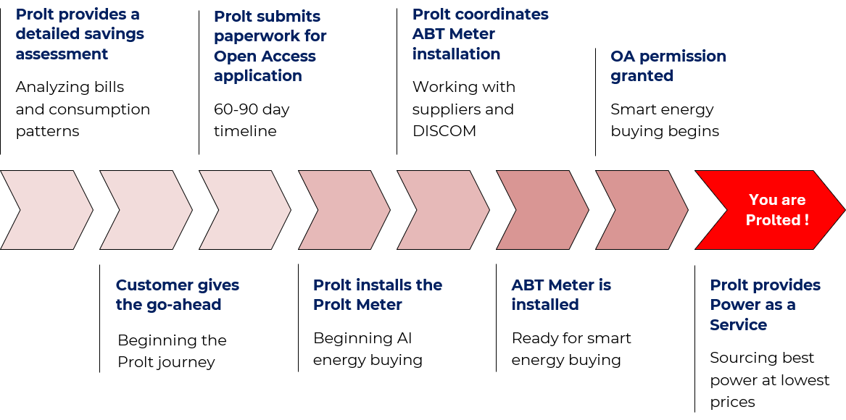

🔍 Prolt analyses historical electricity bills, consumption patterns, tariff structure, and load profile to identify suitable energy procurement opportunities and estimate the potential monthly and annual savings.
✅ Customer provides the go-ahead to initiate the Prolt journey and proceed with the required regulatory, metering, and implementation activities.
📄 Prolt prepares and submits the required Open Access documentation with SLDC/DISCOM and manages the necessary coordination and follow-ups. The indicative approval timeline is approximately 60–90 days.
📊 In parallel, Prolt installs the Prolt Meter at the facility to begin monitoring consumption and establish the data foundation for forecasting, procurement planning, and AI-enabled energy buying.
🤝 Prolt coordinates with the meter supplier, contractor, DISCOM, and site team for ABT Meter installation, including documentation, scheduling, inspection, and commissioning support.
⚙️ Once the ABT Meter is installed and commissioned, the facility becomes technically ready for Open Access power procurement and scheduling.
⚡ After Open Access permission is granted, Prolt begins smart energy buying by evaluating demand requirements, market prices, and available power sources to optimise procurement cost.
💰 Prolt continues to manage procurement planning, market monitoring, scheduling, reconciliation, consumption tracking, and savings reporting under its Power as a Service model, helping customer achieve sustained energy savings with complete visibility.

11. WHY PROLT ENERGY
A Single Accountable Partner for Technology, Markets, and Execution.
Energy savings are not created by analysis alone. They require the right combination of data intelligence, market access, regulatory understanding, procurement planning, and continuous operational execution.
Prolt Energy brings all of these capabilities together under one managed service, helping industrial and commercial consumers move from conventional electricity purchasing to a smarter, data-driven energy procurement model.
Instead of working with multiple consultants, traders, technology providers, and monitoring platforms, customers get one accountable partner responsible for identifying savings opportunities, enabling procurement, monitoring performance, and demonstrating realised savings.
STEP 1  Diagnostic Study  Assessment of current power cost, load profile, tariff structure, and alternate procurement opportunity. | STEP 2  Managed Energy Service  Procurement planning, market monitoring, scheduling, reconciliation, savings tracking, and reporting.
Understand the Opportunity Before Taking Action  The engagement begins with a detailed assessment of the consumer's existing electricity consumption, tariff structure, demand profile, and procurement pattern.  The diagnostic study covers:  - Historical electricity bill and tariff analysis  - 15-minute / time-block load profile assessment  - Contract demand and maximum demand analysis  - TOD-wise consumption and cost evaluation  - Identification of high-cost procurement periods  - Assessment of Open Access and alternate procurement potential  - Comparison of utility tariff versus market-based procurement options  - Evaluation of renewable and conventional power sourcing opportunities  - Initial savings estimation and commercial viability  - Assessment of metering, connectivity, and implementation readiness  The outcome is a clear, data-backed understanding of how much energy can potentially be procured differently, what savings can be achieved, and what implementation approach is best suited to the facility. | Convert Identified Potential into Realised Savings  Once the opportunity is validated, Prolt supports the customer through the complete energy procurement lifecycle.  The Managed Energy Service includes:  - Energy procurement planning  - Day-ahead and real-time market monitoring  - Consumption and demand forecasting  - Procurement optimisation across available sources  - Power scheduling and operational coordination  - Open Access process support  - Market price and tariff monitoring  - Settlement and reconciliation support  - Actual-versus-scheduled energy analysis  - Savings tracking and performance reporting  - Exception and deviation monitoring  - Management dashboards and periodic insights  - Continuous optimisation based on changing consumption and market conditions  This ensures that the recommendation does not remain a theoretical savings estimate. Prolt continuously tracks procurement performance and converts identified opportunity into measurable financial savings.

BUY BETTER POWER. AT BETTER PRICES. WITH BETTER VISIBILITY.

12. WHY THE PROLT MODEL IS DIFFERENT
One Platform. One Service. One Accountability Layer.
Traditional energy procurement often operates through disconnected stakeholders — one party performs an audit, another manages market transactions, another provides metering, while the consumer's internal team has to reconcile the results.
Prolt integrates the entire process.
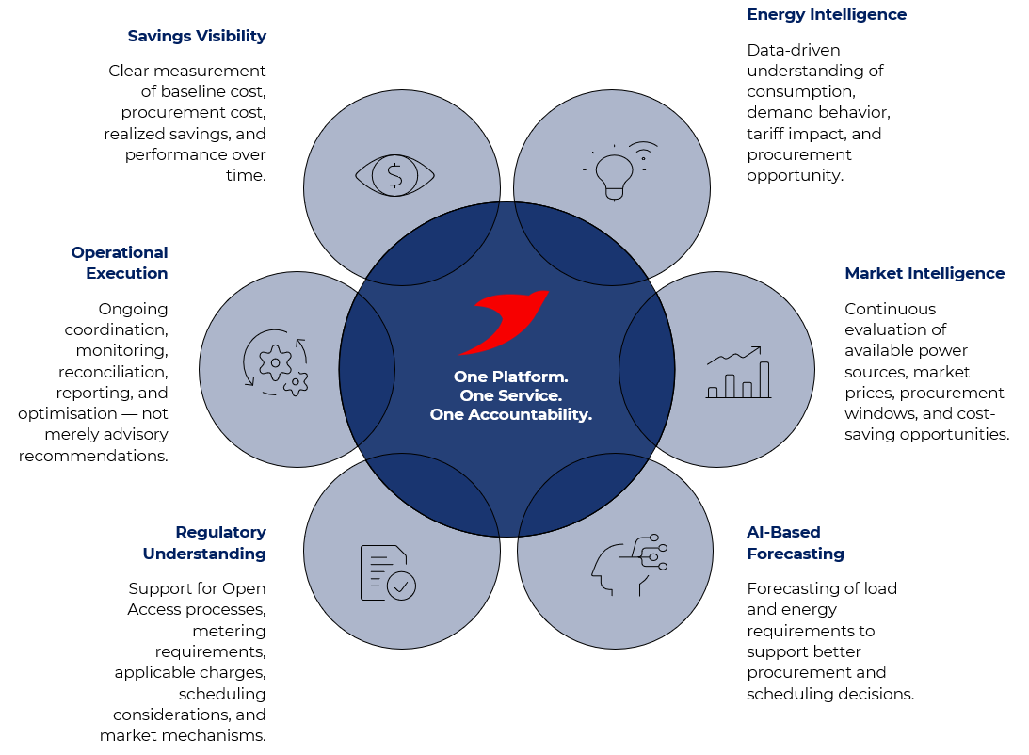
BUILT BY PROBUS SMART THINGS.
Prolt Energy is built by Probus Smart Things, a technology company with deep experience across the energy and power ecosystem. Probus brings capabilities in:

- Energy monitoring and analytics
- Smart metering and AMI
- Distribution grid digitisation
- IoT and communication systems
- Transformer and asset monitoring
- Remote data acquisition
- Energy dashboards and analytics
- AI/ML-driven insights
- Utility and industrial energy applications


This technology foundation enables Prolt to go beyond traditional energy consulting by combining real-time data, software intelligence, market understanding, and operational execution within a unified service.

13. SUMMARY & NEXT STEP
Recommendation: Begin the Implementation Journey Now.
The historical energy consumption and billing analysis demonstrates a strong business case for transitioning to Prolt Energy. By intelligently sourcing power through lower-cost procurement options, the facility can significantly reduce energy expenditure while maintaining reliable supply.
PROCUREMENT POTENTIAL | AVERAGE MONTHLY SAVINGS | FIXED-COST PAYBACK
Approximately 95%  of the energy requirement during lower-cost daytime hours or cheaper available options, optimised against the facility’s 24-hour consumption profile. | ₹2,11,034  Based on the actual energy bills shared with Probus. | Less than 150 days  After payback, energy savings improve operating margins.

Lower energy costs. Faster payback. Savings from Day 1.

Why Act Now?

The analysis indicates a substantial opportunity to reduce recurring electricity costs without requiring changes to the facility's core operations. Moving to an optimised energy procurement model can help the organisation achieve:

- Immediate reduction in energy procurement costs
- Predictable and measurable monthly savings
- Rapid return on implementation investment
- Improved operating margins after payback
- Smarter procurement decisions using actual consumption data
- Greater visibility and control over energy expenditure

NEXT STEP  Approve the Open Access implementation and metering process so Probus can begin the transition to smart energy buying.  Visit prolt.energy, upload your energy bills, and instantly discover how much your business can save. |   GET  PROLTED

Submitted by Prolt Energy
A Probus Smart Things Initiative
